NAME: SAGARSUMAN P MANJHI SUBJECT: PYTHON PROGRAMMING LAB | PRACTICAL: 05 | BATCH : 04  SYBVOC :SEM-III (DS)
Experiment Based on Looping Statements

AIM : To write a Python program to simulate an ATM withdrawal system using a while loop and demonstrate the use of loop control statements (break, continue, and pass) for controlling program execution.
LEARNING OBJECTIVE :
  - To understand looping statements in Python.
  - To learn the use of while and for loops.
  - To understand break, continue, and pass statements.
  - To control program execution using loop control statements.
  - To improve programming and logical thinking skills.
TOOLS :

Sr. No. | Name Of Resources | Specification | Quantity | Remarks
1. | Hardware | Computer (i5-i7) Ram (Min 16GB) | 1 | For All Practical
2. | Software | Python / IDLE / VS Code | 1 | For All Practical
THEORY :
1. Looping Statements:
Looping statements are used to execute a block of code repeatedly until a specified condition is satisfied.
2. for Loop: A for loop is used to iterate over a sequence such as a list, tuple, or string.
Example:
for i in range(5): print(i)
3. while Loop: A while loop repeatedly executes a block of code as long as the given condition is true.
Example:
balance = 5000while balance > 0: print(balance) break
4. break Statement: The break statement immediately terminates the loop.
Example:
for i in range(5): if i == 3: break print(i)
5. continue Statement: The continue statement skips the current iteration and moves to the next iteration of the loop.
Example:
for i in range(5): if i == 2: continue print(i)
6. pass Statement: The pass statement performs no operation. It is used as a placeholder when a statement is required syntactically.
Example:
if True: pass

Source Code:
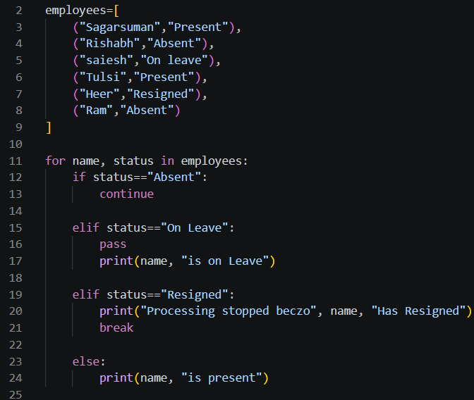
Output:
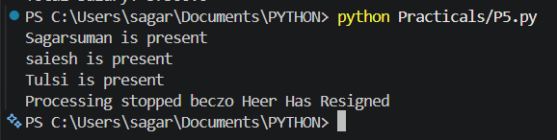
Result and Discussion:
The program successfully demonstrates the use of looping statements and loop control statements in Python. The continue statement skips employees marked absent, the pass statement acts as a placeholder for the on-leave condition, and the break statement stops the loop when an employee has resigned.
Learning Outcomes:
- Understood looping statements in Python.
- Learned to use for and while loops.
- Understood the functions of break, continue, and pass.
- Learned to control program execution using conditions.
- Improved logical thinking and programming skills.
Course Outcomes:
- Developed Python programs using loops and conditional statements.
- Applied loop control statements to practical situations.
- Understood iteration over lists and tuples.
- Improved problem-solving and programming skills.
CONCLUSION :
The program successfully demonstrates looping and loop control statements in Python. It shows how continue skips an iteration, pass acts as a placeholder, and break terminates a loop when a specified condition is met.

VIVA QUESTIONS :

1. What is a loop in Python?
A loop is used to execute a block of code repeatedly.

2. What is a for loop?
A for loop iterates over a sequence such as a list, tuple, or string.

3. What is a while loop?
A while loop executes a block of code repeatedly as long as a condition is true.

4. What is the use of the break statement?
The break statement immediately terminates the loop.

5. What is the use of the continue statement?
The continue statement skips the current iteration and proceeds to the next iteration.

FOR FACULTY USE ONLY :
Correction Parameters | Formative Assessment [40%] | Timely completion of practical [40%] | Attendance/ Learning Attitude [20%]
Marks Obtained

